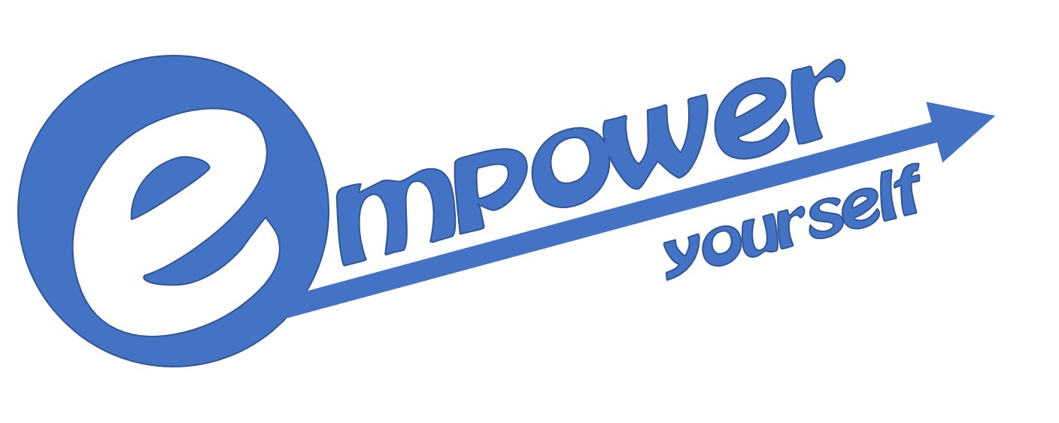Empower Yourself – the Norwegian contribution
Bjerkaker LearningLab (BLL) is the Norwegian partner of the Erasmus + project Empower yourself – motivation tools for supporting professional activity and wellbeing of people 55 +, project no. 2020-1-PL1-KA204-082149. The project is coordinated by the Polish Spread your Wings Foundation, and a third partner comes from Hungary: Humán Innocáviós Csoport Nonprofit Kft (HICS).
The project is a complex developmental program, addressing the issues of social and professional exclusion among Europeans in their preretirement age. The project will emphasize tools as recurrent education as well as creating conditions for employees’ 55 + development.
On behalf of BLL, Tor Inge Martinsen and Sturla Bjerkaker will be the main Norwegian contributors, both are long standing adult educators with experiences from projects for and by seniors and more.
The main tasks for BLL in the project are:
- Develop and complete a study on Norwegian strategies and measures to make seniors remain at work. This will be completed as a report, or small handbook, in June 2021.
- To develop two evaluation tools, one for evaluating the project meetings, and one for evaluating a planned project meeting and study trip to Norway. These tools were completed in March 2021.
- Plan and host a study trip and international project meeting in Norway, preferable in October 2021.
- Facilitate workshops where the Norwegian study will be presented.
- Organize dissemination activities.
The duration time of the project is 18 month, and it will last until 28.02.2020.

Oslo, 12.04.2021
BLL
Sturla Bjerkaker

